Project Title

Cryptographic Engine v2.0
Submitted by : M. Ammar Khan

Project Overview
This project is a Cryptographic Engine developed using Python and Tkinter. It implements the Caesar Cipher algorithm to encrypt and decrypt text using a user-defined shift key.
This project is part of the DecodeLabs Cyber Security Internship Program (Batch 2026).

Features
- Encrypt text using Caesar Cipher
- Decrypt encrypted text back to original
- Random key generator (1–25)
- Copy output to clipboard
- Character counter
- Clear all fields option
- Interactive and user-friendly GUI

Algorithm Used
Caesar Cipher Algorithm
Encryption Formula: (x + shift) mod 26
Decryption Formula: (x - shift) mod 26

Technologies Used
- Python
- Tkinter
- Random module

How to Run
- Install Python on your system
- Open terminal or command prompt
- Run the file using:
python main.py

Screenshots
(Add screenshots in Word document)
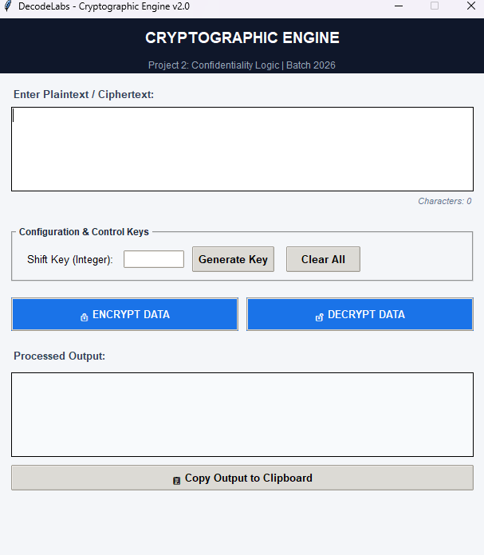
- Screenshot 1: Main Interface

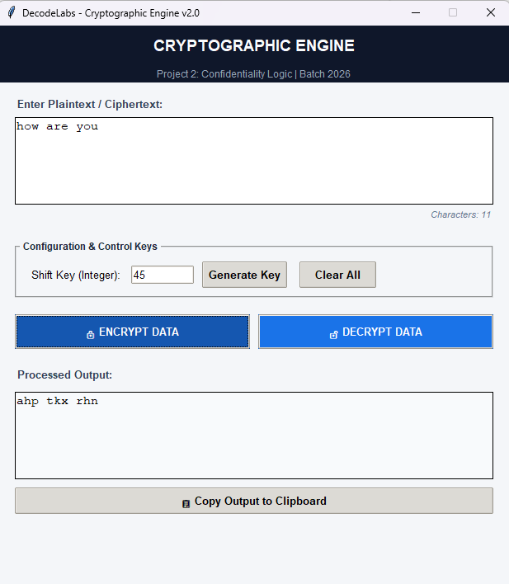
- Screenshot 2: Encryption Process

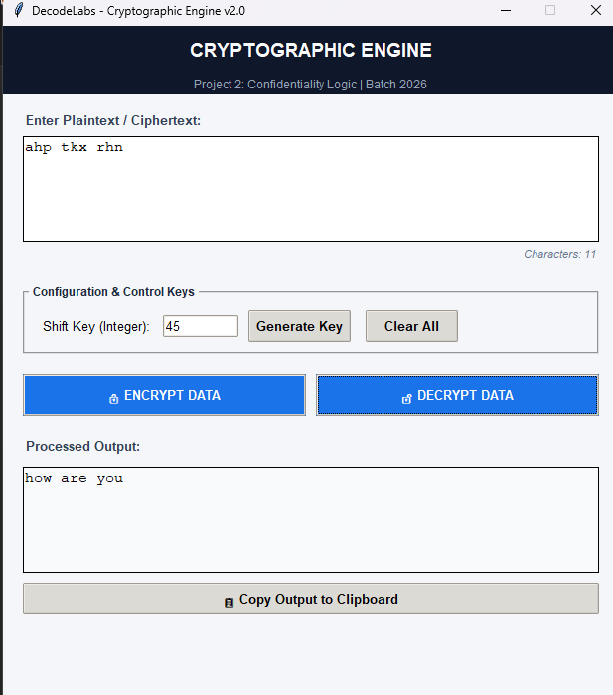
- Screenshot 3: Decryption Process

- Screenshot 4: Random Key Generator
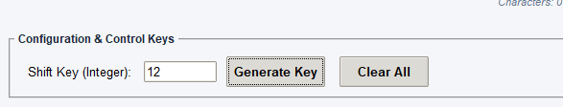

Developer
Ammar Khan

Internship Program
DecodeLabs Cyber Security Program 2026

